1. Added target and module in Prometheus yml file.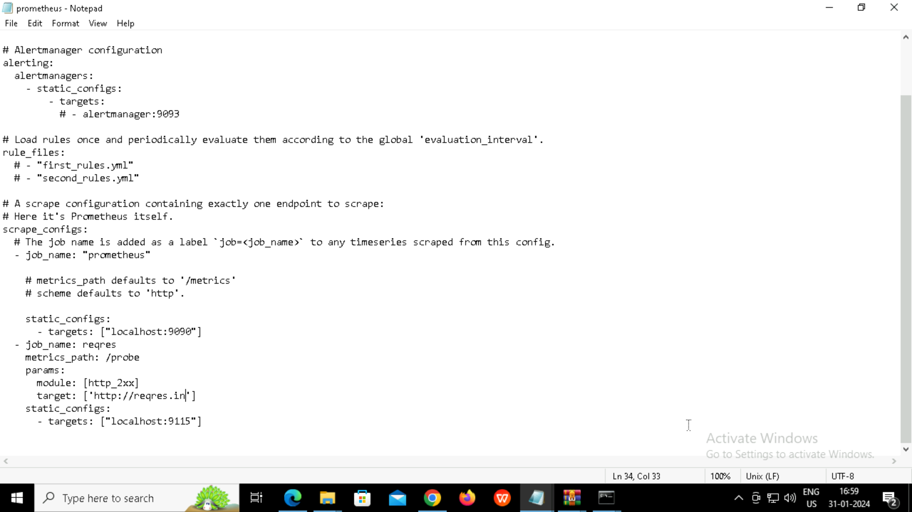

2.probe dns lookup time seconds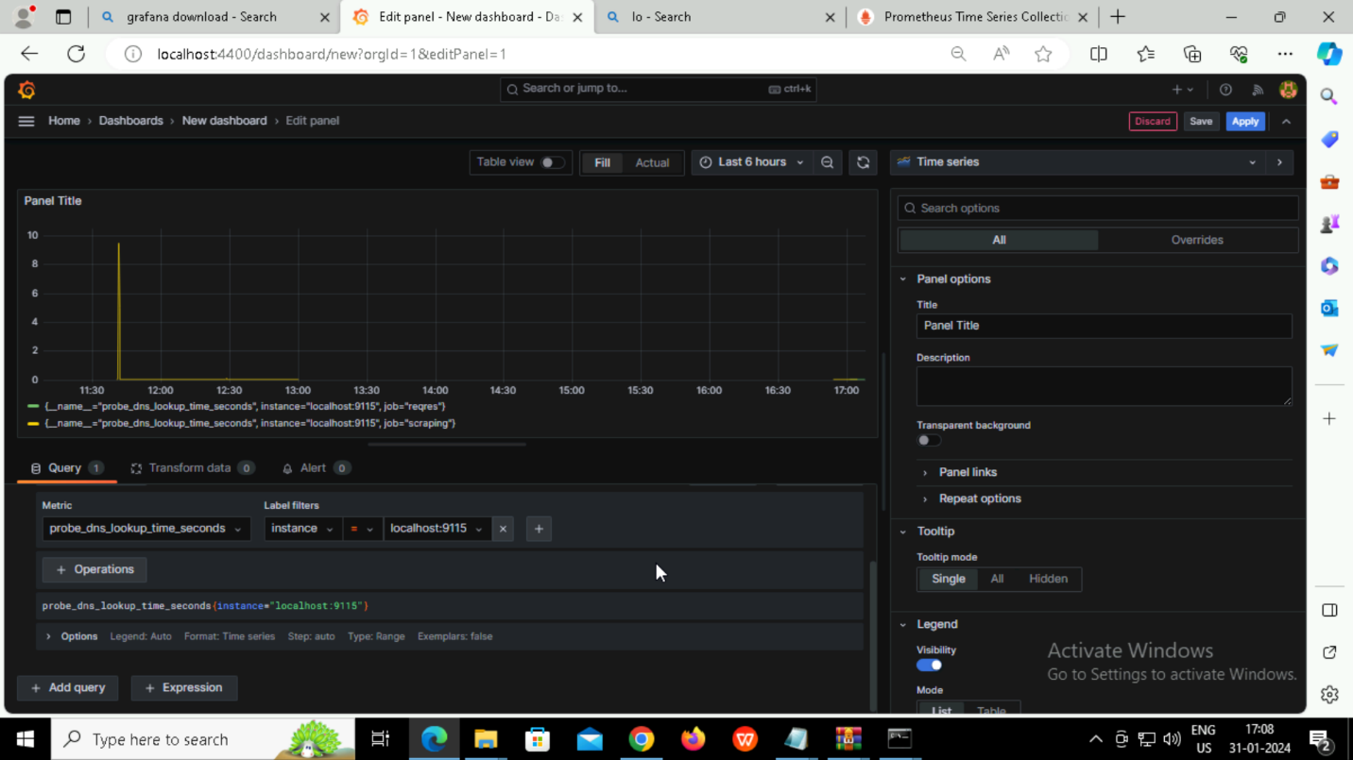

4. Probe duration seconds

